SmartCare v0.1 - Initial Engineering Brief and AI
Activity Card
A2 Case Study Stage 1 student resource
SmartCare scenario
SmartCare Community Clinic currently uses spreadsheets and paper records to manage patients and appointments. The client says: 'We need software to help manage patients, practitioners and appointments.'
This is not yet a complete specification.
Initial Engineering Brief
1. Problem summary

Smartcare community clinic uses outdated spreadsheets and paper records to manage their patients and appointments. The problem is making software to allow this clinic to efficiently manage their patients and practitioners as well as book appointments easily. The software should stop double bookings and allow easy access to patient medical info for the practitioners.

2. Initial stakeholders
Stakeholder | Possible need
Clinic receptionists | A fast and efficient way to schedule appointments and patient records.
Doctors and nurses | Fast, efficient and up to date medical info on patients.
Patients | 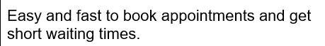
Clinic management | 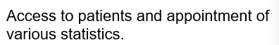

3. Initial features
Feature | Confirmed or provisional? | Why?
Add appointments | confirmed | The client specifically asked for this.
Stop double booking appointments. | confirmed | The client specifically asked for this.
Practitioner schedule view. | confirmed | The client implied that this was required.
Patient search. | confirmed | The client specifically asked for this.

4. Questions for the client
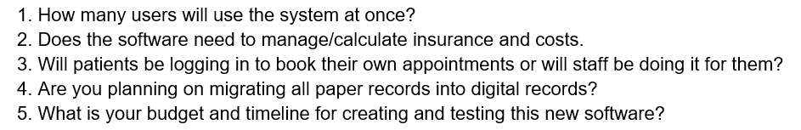

5. What we do not yet know

AI Activity Card - Ask, Check, Explain

Assuming the code you're referring to is the one from stage 1 lab.
Before AI
What do I think the code does? What problems can I already identify?
The code displays the appointments that are hardcoded into it.
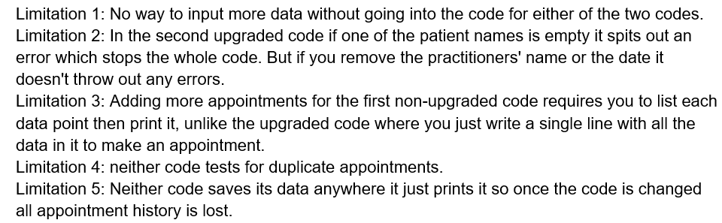

AI request
Act as a tutor. Explain this code and identify potential problems. Do not provide a complete replacement. Ask me questions that help me reason about the solution.
Can be found in ai_usage.md

Evaluate

Suggestion | Useful | Unclear | Incorrect | Out of scope
Refactor away from a global list | 0 | 0 | 0 | 1
Add validation for more than just patient name. | 0 | 0 | 0 | 1
Store time as a proper date/time object instead of raw string. | 0 | 0 | 0 | 1
Separate data storage, business logic and output. | 0 | 0 | 0 | 1

Decide
For each significant suggestion: Accept / Modify / Reject / Keep unverified.

Reject each because it is out of scope for stage 1

Verify
• Run the code
• Test normal input
• Test unusual input
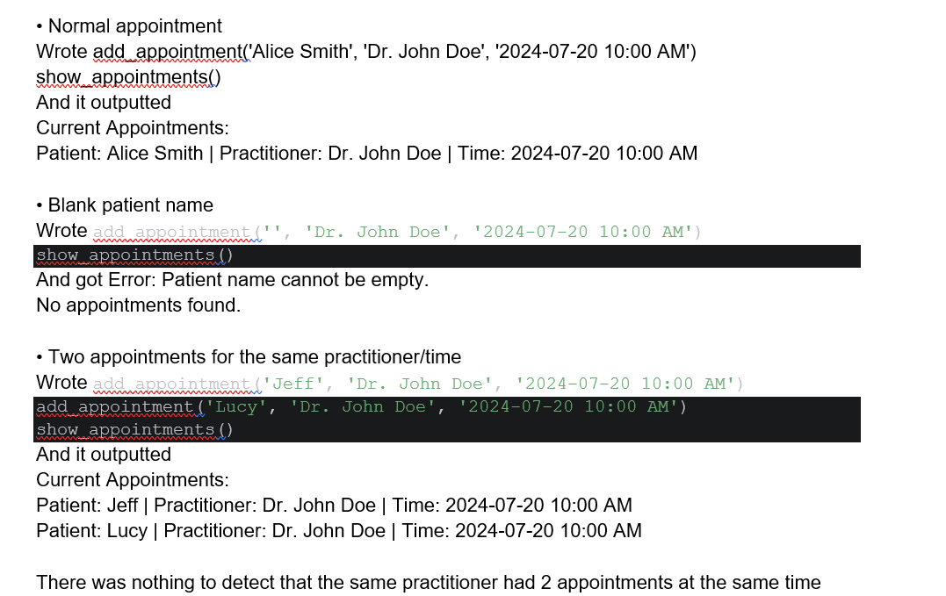
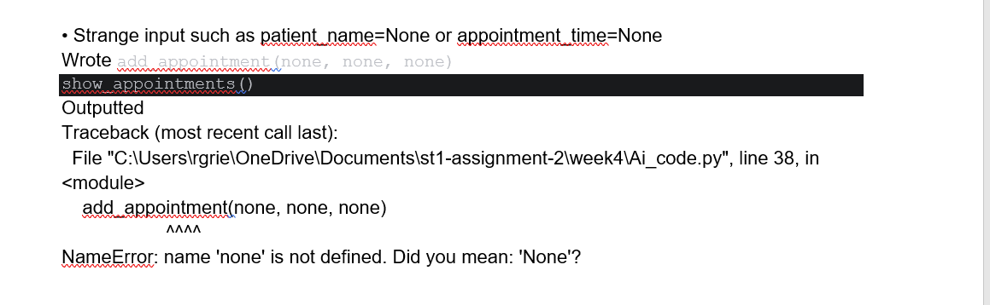
• Compare with requirements
• Ask tutor/peer
• Check documentation

Explain
This code here #task1enhanced
# Use lists, dictionaries and functions to enhance the Python file

appointments = []

def book_appointment(patient_name, practitioner_name, appointment_time):
if not patient_name:
raise ValueError("Patient name cannot be empty")
appointment = {
"patient": patient_name,
"practitioner": practitioner_name,
"time": appointment_time
}
appointments.append(appointment)

def display_appointments():
if not appointments:
print("No appointments recorded.")
return
for appointment in appointments:
print(f"Patient: {appointment['patient']} | Practitioner: {appointment['practitioner']} | Time: {appointment['time']}")

print("Welcome to SmartCare: The Clinical Appointment Booking System!")
book_appointment('Alice Smith', 'Dr. John Doe', '2024-07-20 10:00 AM')
book_appointment('Bob Johnson', 'Dr. Jane Roe', '2024-07-20 11:30 AM')
display_appointments()

Creates an empty list where appointments will be stored
Defines a function that creates appointments with 3 pieces of information.
Checks if patient name is empty
Puts the 3 pieces of information into dictionary
Puts that dictionary into the appointment list
Defines a function to show appointments
Checks if list is empty
Prints list
Prints welcome message and calls functions

